Weikun Zhang

2358826z

This program assume that the keyword inputted by user is a combination of alphabets but not any other characters. The keyword should contain no more than 26 alphabets, in which each letter cannot be repeated. Furthermore, it is assumed that there is already a file whose name ended up with the letter of whether capital “P” or capital “C” and existed in the same folder with the other “.java” files.

Overall, the program works properly and meets all the requirements of this exercise.

To test the program, a “CommonP.txt” file with the content of “HELLO WORLd!!!” was first used as input. The keyword is “Tiger” and the MonoAlphabetic cipher was used to encode the file. According to the encryption array, the expected output should be “CRJJM WMPJd!!!” written in “CommonC.txt” file together with another “CommonF.txt” file that prints out the frequencies. As it is demonstrated in fig 1, the output is the same as expected. The decoding method was then tested by entering the file name “CommonC” and it was found that the content of “CRJJM WMPJd!!!” was decoded back to “HELLO WORLd!!!” which is exactly as expected.

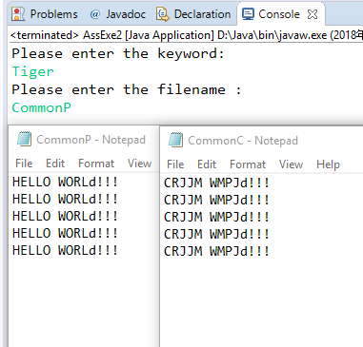

Figure 1: Encode CommonP to CommonC through MonoAlphabetic cipher

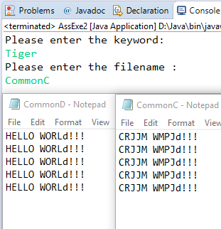

Figure 2: decode CommonC to CommonD through MonoAlphabetic cipheR

Shown as Fig 3, the same “CommonP.txt” file was used to test another cipher. In order to test the Vignere cipher, we just need to comment the first line and uncomment the second line, as a polymorphism approach was used here. As a result, the output of “CommonP.txt” file is “AMRPF PWXPd!!!” ……. together with another “CommonF.txt” file which displayed the frequencies as required. This indicates that the Vignere works properly. (Fig 5)

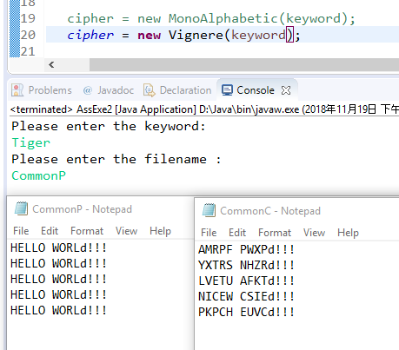

Figure 3: Eecode CommonP to CommonC through Vignere cipher

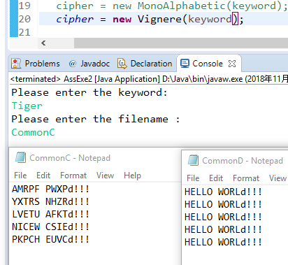

Figure 4: Decode CommonC to CommonD through Vignere cipher

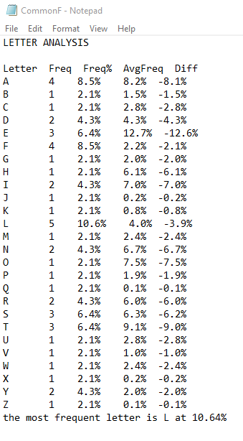

Figure 5: Example for Letter Frequencies

Finally, this program also has the ability to handle the exceptions for some incorrect input such as a repeated keyword (Fig 6), a wrong format of file name (Fig 7) and a non-existence of “CommonP” as well as “CommonC” file (Fig8).

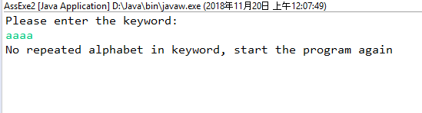

Figure 6: Example for Letter Frequencies

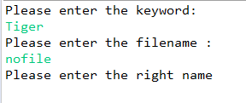

Figure 7: Example for Letter Frequencies

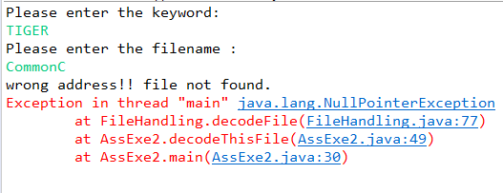

Figure 8: Example for Letter Frequencies